REGISTRATION FORM

Please write legibly and answer all elements of the registration form

TITLE
SURNAME
FIRST NAME(S)
DATE OF BIRTH (DD/MM/YYYY)
Copy of ID or passport will be required
COUNTRY YOU ARE REPRESENTING
PLACE OF EMPLOYMENT + CITY
PHONE NUMBER
E-MAIL
PHONE
FACEBOOK ACCOUNT
INSTAGRAM ACCOUNT

BIOGRAPHY

A brief paragraph about your professional background. Please feel free to add anything relevant to your professional career here, for example: previous competition wins or awards.

You may also include any interests or passions you have, and please include your inspiration for this competition and how you linked your cocktail to the theme.

Eg: Paul was born in London but spent two years in Scotland, and has an Irish heritage and Scottish ancestry, which inspired his MONIN Cup drink for the regional heat. Before joining the Sugar Bar in London in 2016, he was bartending at the Last Word Saloon in Edinburgh for over a year and spent six months bartending in various hotels in Wales. Paul is passionate about football and tequila, which gives him the ambition to create his own brand of tequila someday. The smell of the football locker room mixed with the smoky taste of Mezcal was what inspired him to create his cocktail.

PICTURE

Portrait style (can also be square or landscape style for the formatting of the file but preferably use portrait), HD quality, uncropped. Please see below for examples. Send it in

Size: 300dpi, minimum 1080 x 1920

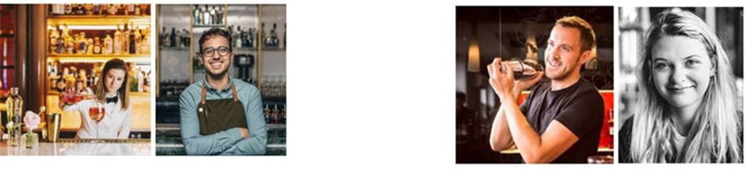

DRINK

MONIN Product(s) chosen

NAME OF THE DRINK

No | ml | RECIPE | BRAND NAME
1

2

3

4

5

…

Please write legibly in block letters. Please use at least 10 ml of MONIN product(s).

Garnish

Shake/ Stir/ Blend/ Build (Tick applicable method)

Glass

Deadline

Checked by

Cocktail recipe + Pictures: Send it in JPEG in attachment of your mail.
Examples | Pictures of your cocktail taking in front with garnishes, focus on the drink with a blurred background if possible. | 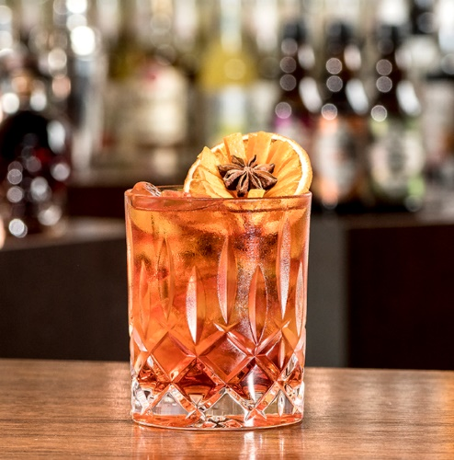
Few words to describe your drink (origin, name)

REMINDER / Please attach to this form

Personal pictures Pictures of your cocktail Copy of ID or passport

______________________________________________________________________________________

CONSENT

I hereby consent that by entering this competition, I give the full right to A.S. Xinaris & Sons Ltd and MONIN, to:
- use all cocktail and drink recipes created and presented during all stages of the competition.
- take photographic and video recording material which may be used for promotional & marketing (website, social media) purposes as well as for archival purposes.
I understand that this material (photographs and videos), may be published on online and in printed media and that it will be stored securely in accordance with the EU General Data Protection Regulation (GDPR-Regulation (EU) 2016/679). I understand that I may withdraw my consent at any time by contracting l.stratis@xinaris.net, and that withdraw will not affect materials already published.

Agree

NAME AND SURNAME

DATE

SIGNATURE

